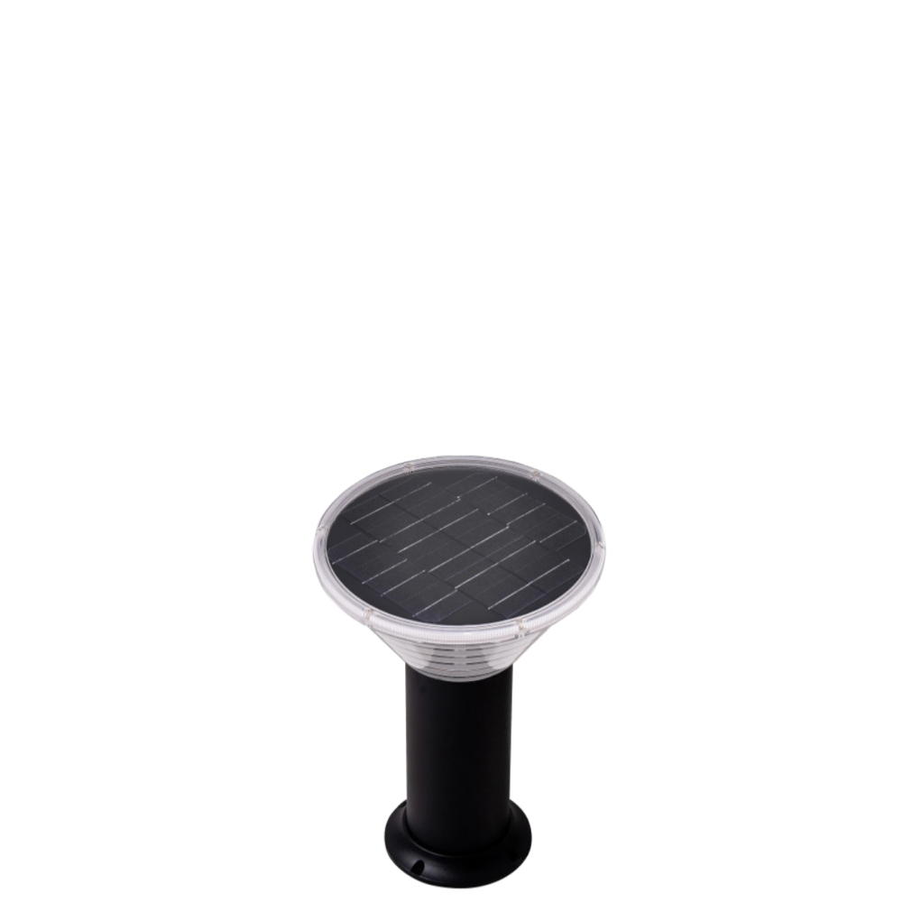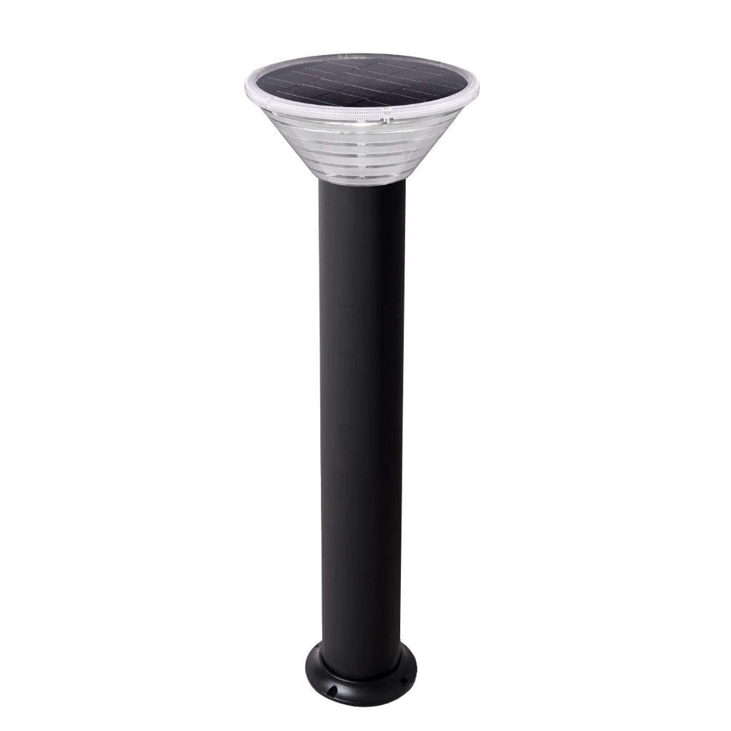

DESCRIPTION

Robustness is achieved with the high-quality die cast aluminum body. The built-in solar panels make this bollard ideal for providing security and ambient lighting to areas without electricity.

|  |  |  |  |
| --- | --- | --- | --- |
| Colour/Height | 480mm | 600mm | 900mm |
| Black | SP-480CSB | SP-600CSB | SP-900CSB |

|  |  |
| --- | --- |
| Light Source | Built in LED |
| Beam Angle | 120° |
| Wattage | 6.2W |
| Power | Solar |
| Diameter | 260mm (at top) |
| IP Rating | IP65 |
| IK Rating | IK10 |
| Charging Time | 6 Hours |
| Battery | 36wH Lithium LifePo4 battery |
| Operation Time | Dusk to Dawn |
| Operating Temp | -10 – +40°C |
| Materials | Aluminium and polycarbonate |
| Lifespan | 40,000hours |

SPECIFICATION

FEATURES

* Superb build quality
* High aluminum post
* 6.2W Mono-Crystalline Solar Panel
* 36wH Lithium LifePo4 battery
* 360° Lighting
* Minimal Maintenance

VARIATIONS