

**CAUTION: RISK OF ELECTRIC SHOCK!**  
WORK MUST BE CARRIED OUT BY AN ELECTRICIAN OR COMPETENT PERSON. IF IN DOUBT, SEEK PROFESSIONAL ADVICE.

**INSTALLATION**

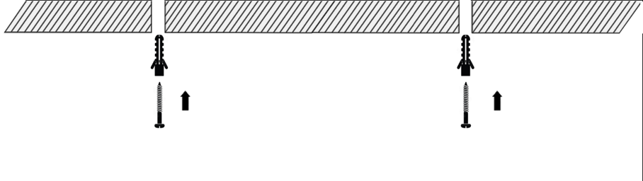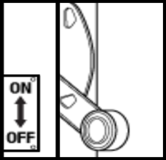

Using appropriate fixings, insert screws into ceiling. Do not screw flush to ceiling, instead leaving 5mm of the top of the screw exposed.

Isolate power to circuit of which light will be installed

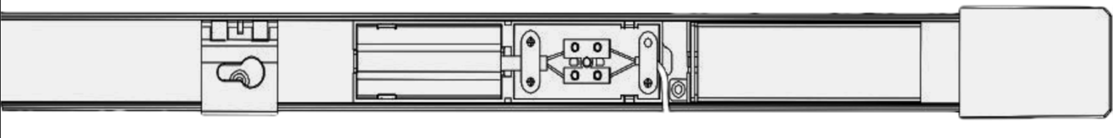

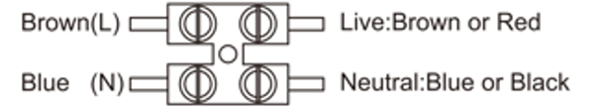

Unclip connection enclosure cover. Connect as shown in diagram (Earth wire is not required). Use cable clamp to keep cable in place. (If there is more than 1no cable to connect, an external junction box may be required.)

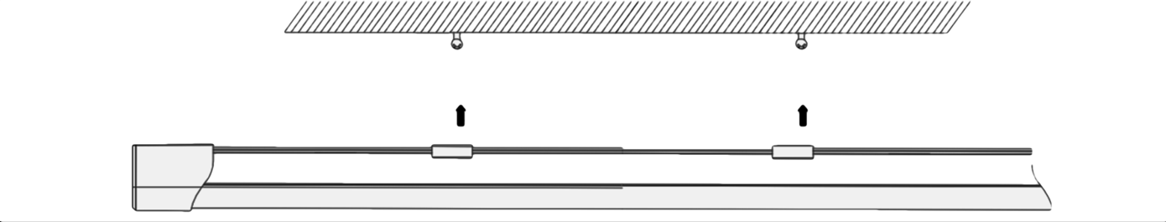

Reattach connection enclosure cover. Dress cable inside light fitting and back into ceiling, line up mounting brackets to screws in the ceiling. Mounting brackets can be slid across fitting to suit location/distance of screws.

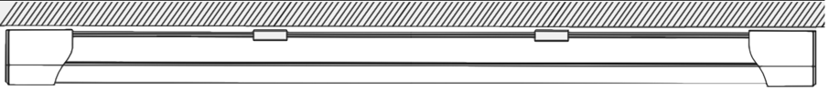

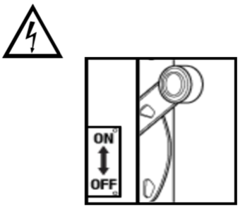

After sufficient testing, power up supply and test further.

Once screws are lined up with mounting brackets, push fitting to the right to lock into place. If fitting does not sit flush with ceiling, screws may need to be adjusted

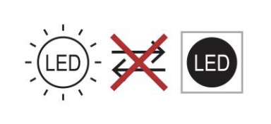

THE LIGHT SOURCE IN THE TRAY CANNOT BE REPLACED. PLEASE DISPOSE OF RESPONSIBILY AND REPLACE THE LED TRAY.

|  |  |
| --- | --- |
| Voltage | AC110-240V |
| Frequency | 50Hz |
| Wattage | 40W |
| Lumens | 4200Lm |
| Power Factor | >0.6 |
| CRI | >80 |
| Lifespan | 25000 hours |
| Installation | Surface |
| IP Rating | IP65 |
| Dimmable | No |
| Beam Angle | 180° |
| Colour Temp | 4000K |

**DISPOSAL**Correct Disposal of This Product (Waste Electrical & Electronic Equipment) (Applicable in the European Union and other European countries with separate collection systems). This marking shown on the product or its literature, indicates that it should not be disposed with other household wastes at the end of its working life. To prevent possible harm to the environment or human health from uncontrolled waste disposal, please separate this from other types of wastes and recycle it responsibly to promote the sustainable reuse of material resources. Household users should contact either the retailer where they purchased this product, or their local government office, for details of where and how they can take this item for environmentally safe recycling. This product should not be mixed with other commercial wastes for disposal.

**FURTHER MAINTENANCE**The fittings are maintenance-free, so never open them. The guarantee becomes void when you open the appliance. Only clean the outside of the devices with a soft, dry cloth or a brush. Prior to cleaning, remove the devices from all voltage sources. Do not use any carboxylic cleaning agents or petrol, alcohol or similar. These damage the surfaces of the devices. Besides, the vapours are hazardous to your health and explosive. Do not use any sharp-edged tools, screw drivers, metal brushes or similar for cleaning.

**GENERAL** **SAFETY**   
Keep all parts out of the reach of children. Avoid dropping or shocks; this may damage the electronic circuits. Repairs or opening of this item may only be done by an authorized repairer. For your safety, always switch off the power supply before changing lamps, adjusting spotlight, heads or cleaning

**HIGH** **VOLTAGE**   
All electrical connections and connection cables must comply with the appropriate rules and match the operating instructions. The fitting must be correctly installed if it is to operate reliably. These instructions and the user guide must therefore be studied carefully. The electrical supply must be switched off at the consumer unit, preferably by means of a switch in the distribution box, before any installation, maintenance or repair work is undertaken. Exterior components must not be installed during rain. Take account of the minimal separation distance from other objects and the room required around the fitting. If in any doubt consult a professional, taking local installation requirements into account. Some countries stipulate that lighting may be installed only by registered installers  
  
**WARRANTY**This product comes with a 2-year warranty (not including lamps). If you have any concerns or questions do not hesitate to contact us.

